# How to create Segments in MailerLite

### What are segments?

Segments are groups of subscribers that are created based on certain criteria you set. They dynamically update, so whenever the values for the criteria you used to define them get updated, the people in those segments update automatically. You don’t have to create them every time someone’s information changes.

Segments are also great because they make sending out emails to select groups of subscribers way easier. Instead of entering the criteria each time you send an email, you just select the email segment you want to send the email to when creating a campaign.

1

2

### How do segments differ from groups?

Groups do *not* dynamically update as the fields used to define them change. These are better for creating **testing** segments, or for when you want extremely manual control over who you’re putting in that group (for instance, you’re sending out a one-time email and don’t need dynamic updating).

For our purposes, we’ll pretty much always want to use segments, even for testing groups.

## Creating a Segment

Go to:

1. Subscribers
2. All subscribers
3. Click on the green ‘Add subscribers’

1

2

3

1. Click on the csv tab
2. Drag and drop your csv file into it.

*Note that you’ll always need email in your csv file, or else some other column (like phone) in order to link the information in your csv to specific subscribers.*

2

1

1. Assign the fields from your csv file to the appropriate fields in MailerLite.

*Note that you can choose to skip assignment – meaning that you can choose not to ignore certain fields in your csv file so they don’t update anything in MailerLite.*

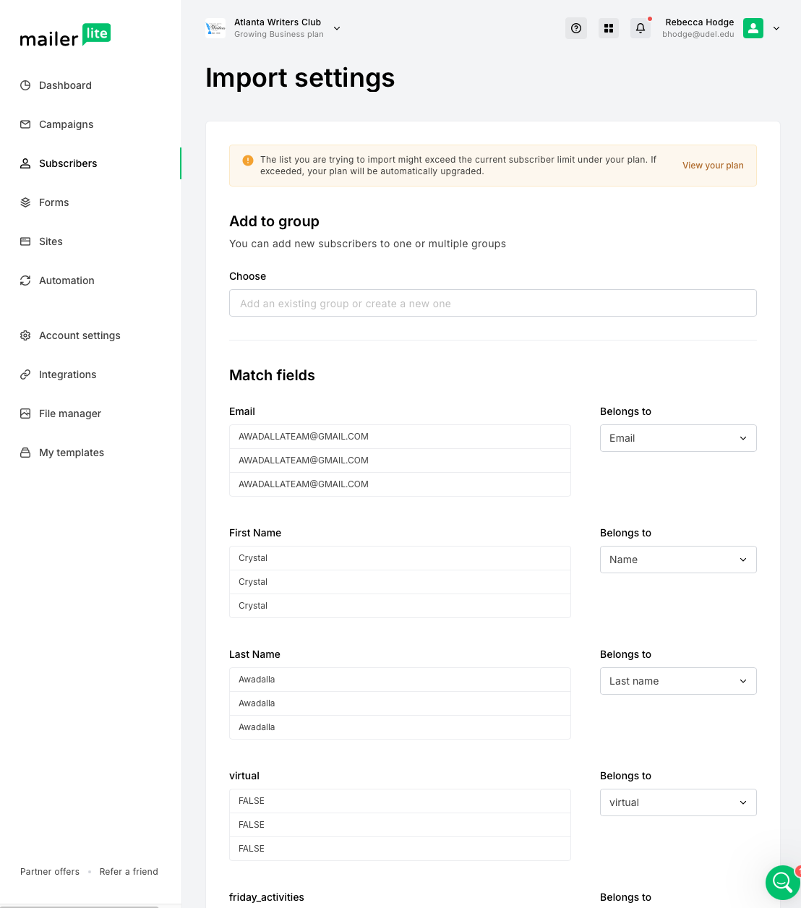

You can choose to skip these two variables (depends on if you think names got updated through conference registration)

1

1. Once you’ve assigned all the relevant fields from your csv file to their respective fields in MailerLite, click done.